Contents

INPUHJPC04133 (JBoss Node1 System) 2

Run HSQL DB 2

Run database manager ( db client to see DB and validate data in future) 3

Run zookeeper 6

Run Kafka 8

Run Configuration Server 9

Run Eureka Server 12

Delete existing deployments 13

Run Jboss on node1 and deploy services 15

INPUHJPC04128 (JBoss Node2 System) 25

Delete existing deployments 25

Run Jboss on node2 and deploy services 27

INPUHJPC01436 (Load Balancer System) 37

Run load balancer 37

# INPUHJPC04133 (JBoss Node1 System)

## Run HSQL DB

1. Go to ‘D:\MasterCardPOC\hsqldb-2.4.1\hsqldb\bin’ in windows explorer.

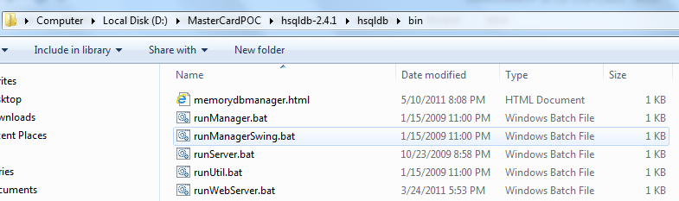

1. Type ‘cmd’ in address bar and press enter:

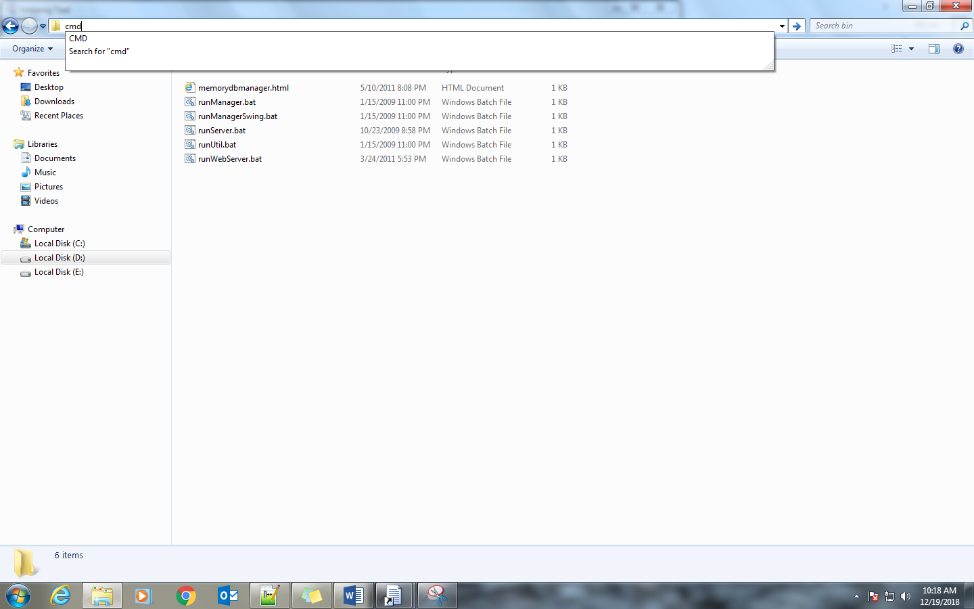

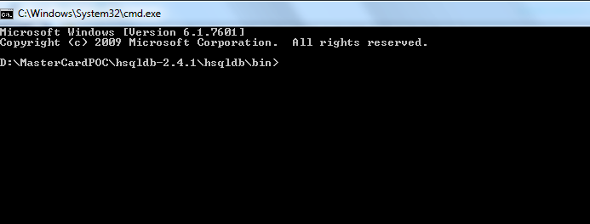

1. Type command ‘runServer.bat’:

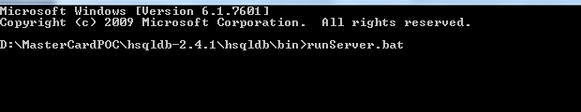

1. Press enter and wait for it to start and reach following state:

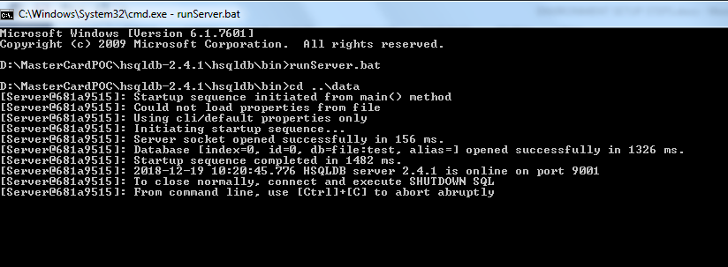

1. Once you see above message, HSQL DB is up and running.

## Run database manager ( db client to see DB and validate data in future)

1. Follow step 1,2 of DB setup and should have following command prompt open:



1. Type ‘runManager.bat’:

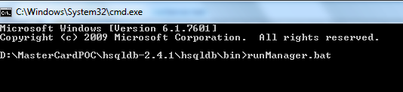

1. Press enter and wait till you see following window:

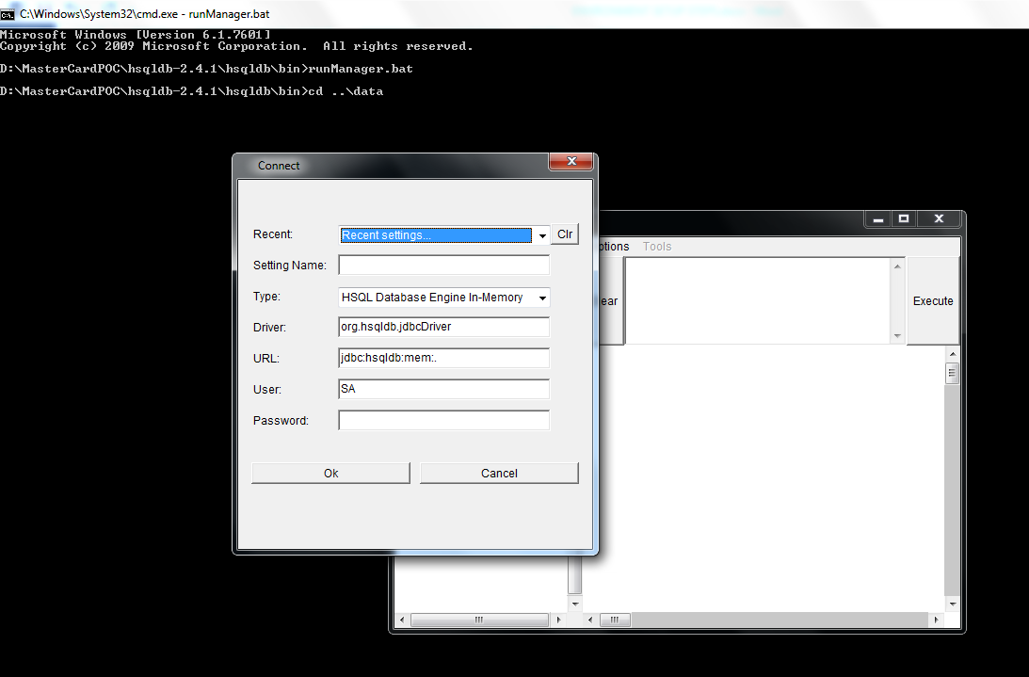

1. Select ‘LocalDB’ in recent dropdown:

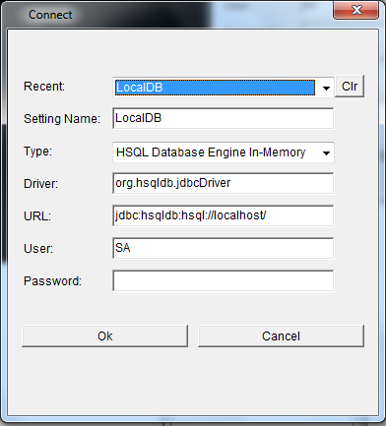

1. Click Ok and you should see a window like following:

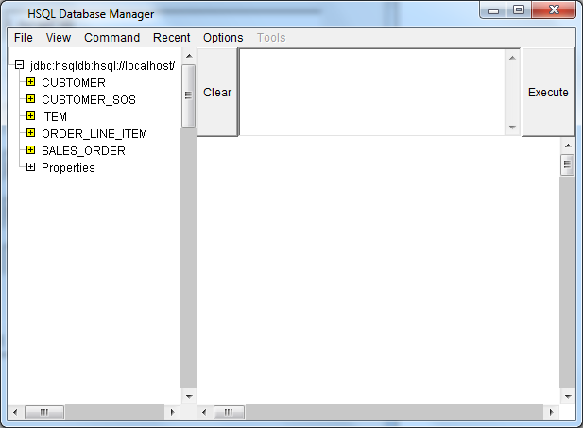

1. If you don’t see any database table(like Item, customer etc) then create tables using following script file:



## Run zookeeper

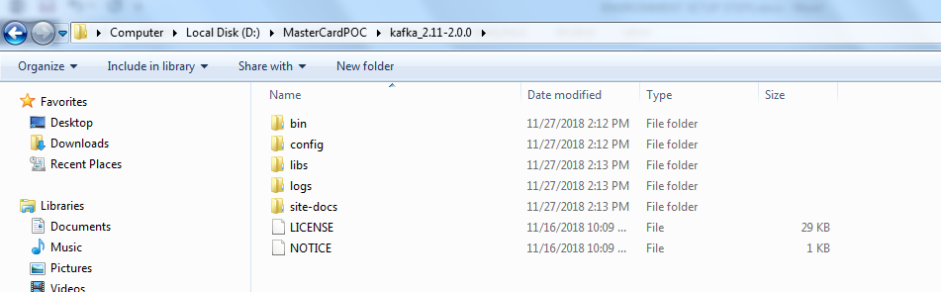

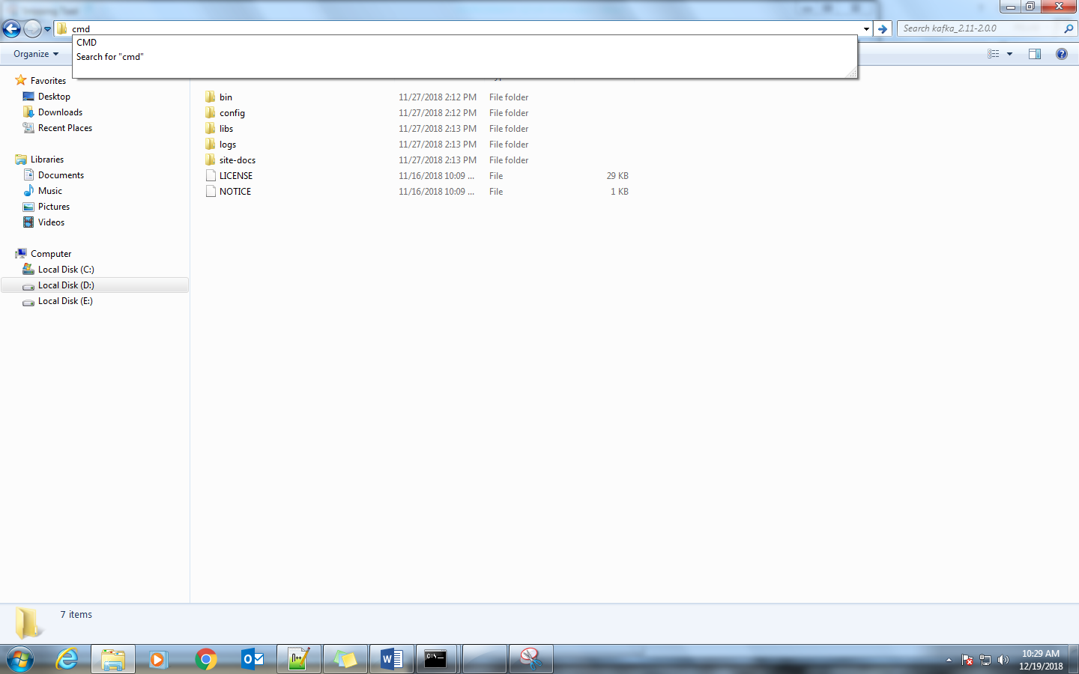

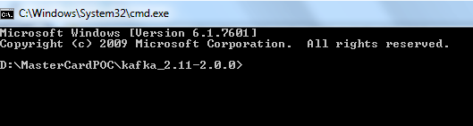

Run command ‘bin\windows\zookeeper-server-start.bat config\zookeeper.properties’

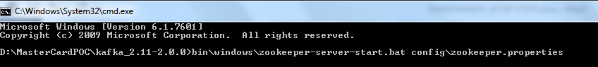

Press enter and wait till you see logs like following:

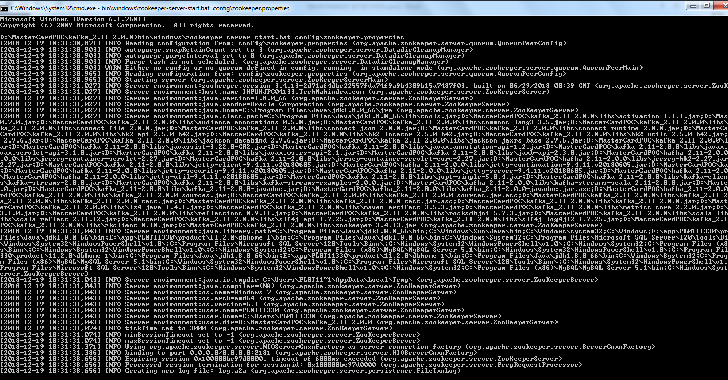

Once you see above logs, consider zookeeper is UP.

## Run Kafka







Run command ‘bin\windows\kafka-server-start.bat config\server.properties’  
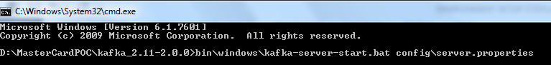

Press Enter and wait till you see logs like following:

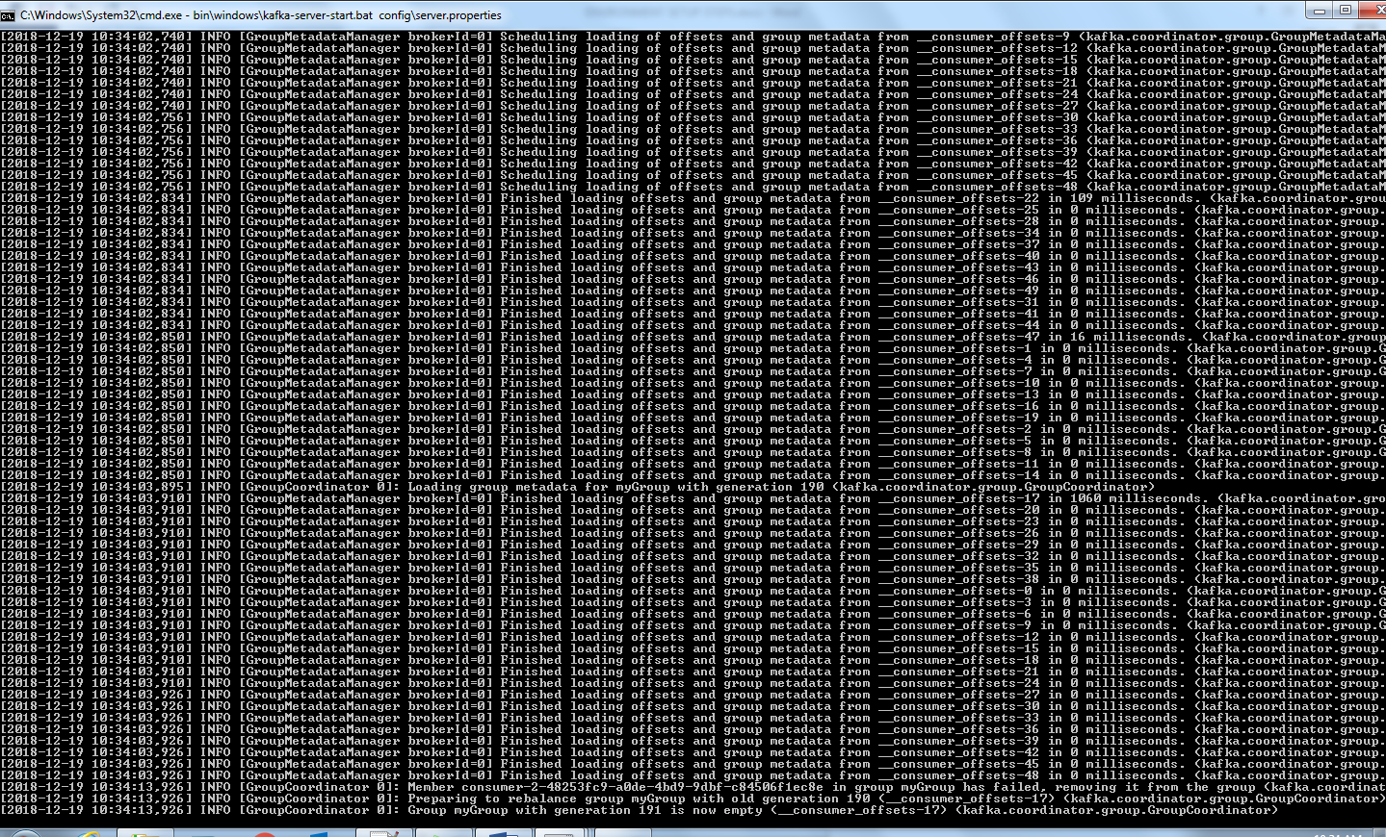

Once you see logs like above, consider Kafka is UP.

## Run Configuration Server

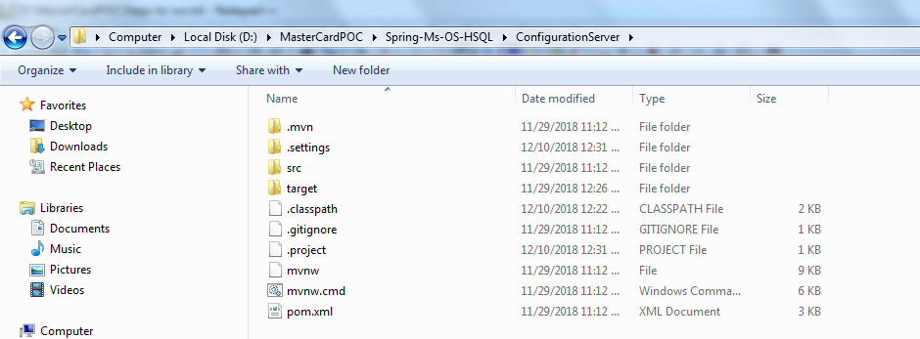

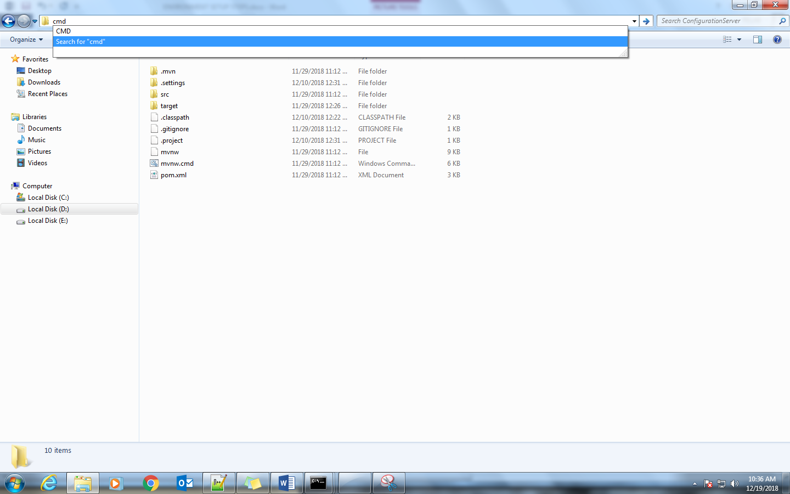

type ‘mvn spring-boot:run’ command:

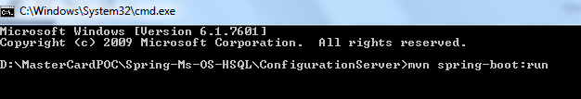

Press Enter and wait till you see following log message:



Configuration Server is UP now if you see above log message. You can validate using following Command:

<http://inpuhjpc04133:5055/item-service-development.yml>

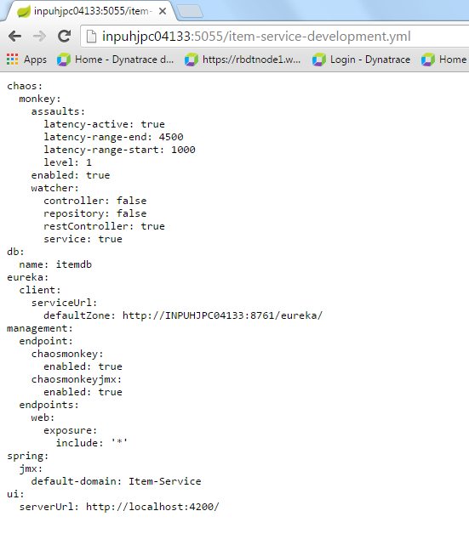

## Run Eureka Server

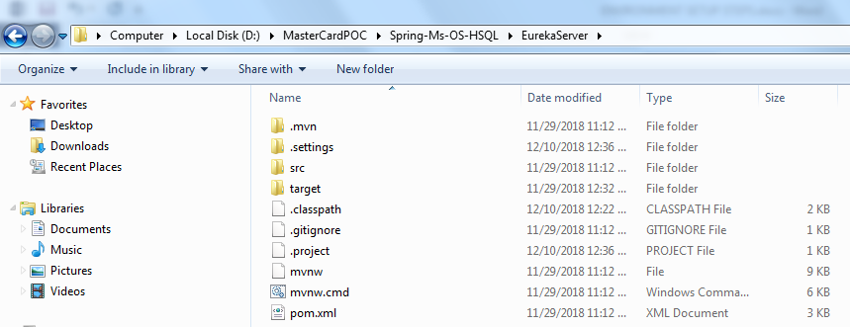

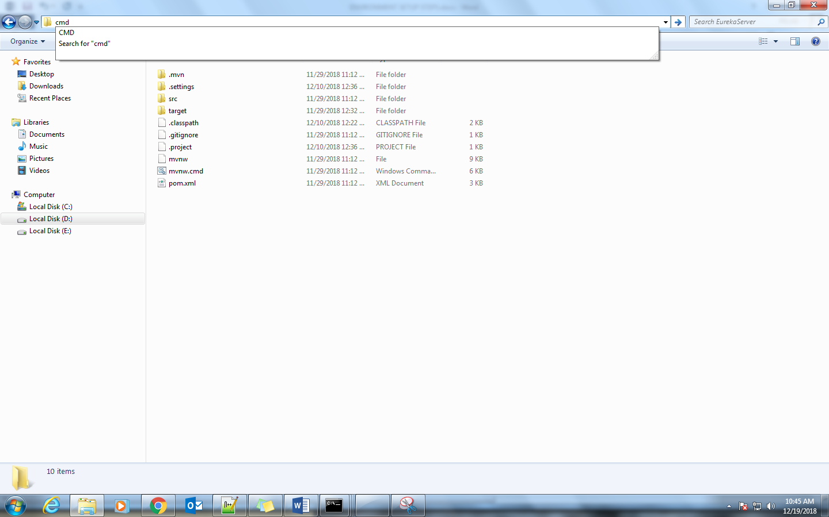

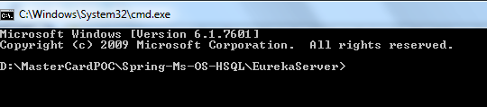

Type command ‘mvn spring-boot:run’

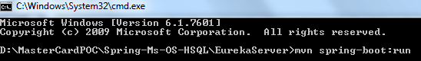

Press enter and wait till you see following log messages:



Eureka Server is UP once you see above messages. You can validate using following URL:

<http://inpuhjpc04133:8761/>

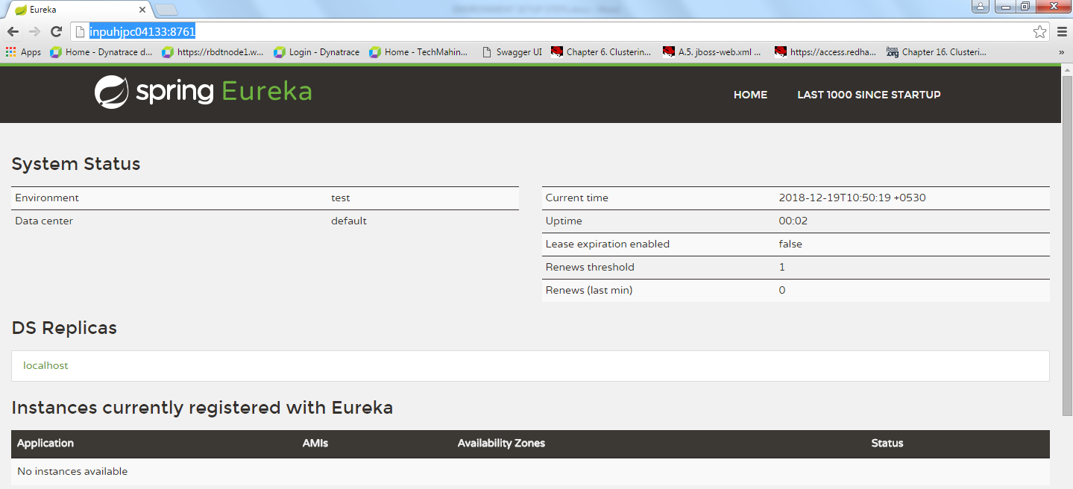

## Delete existing deployments

Delete ‘tmp’ directory from location ‘D:\MasterCardPOC\jboss-eap-7.1\standalone’

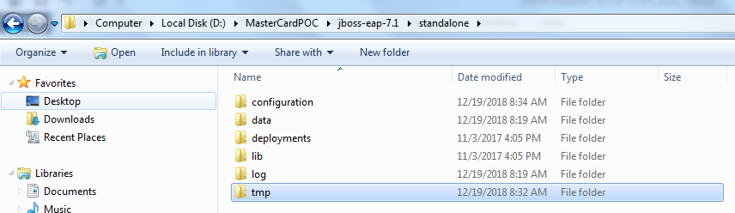

Delete ‘content’ directory from location ‘D:\MasterCardPOC\jboss-eap-7.1\standalone\data’

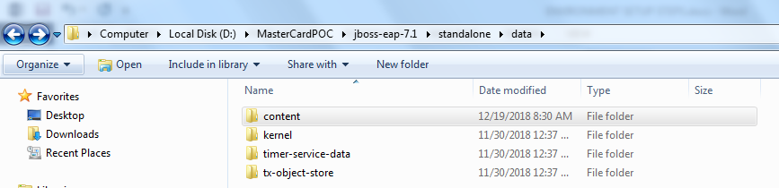

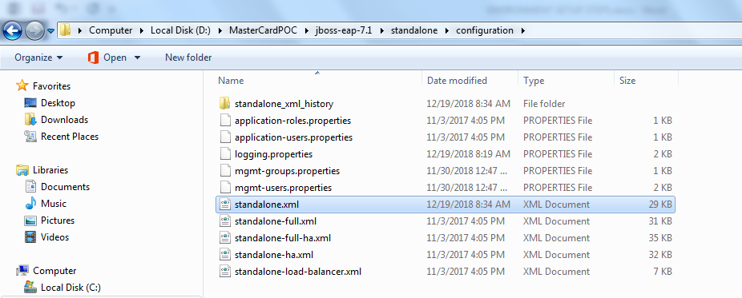

Open ‘standalone.xml’ in editor:

Go to end of file:

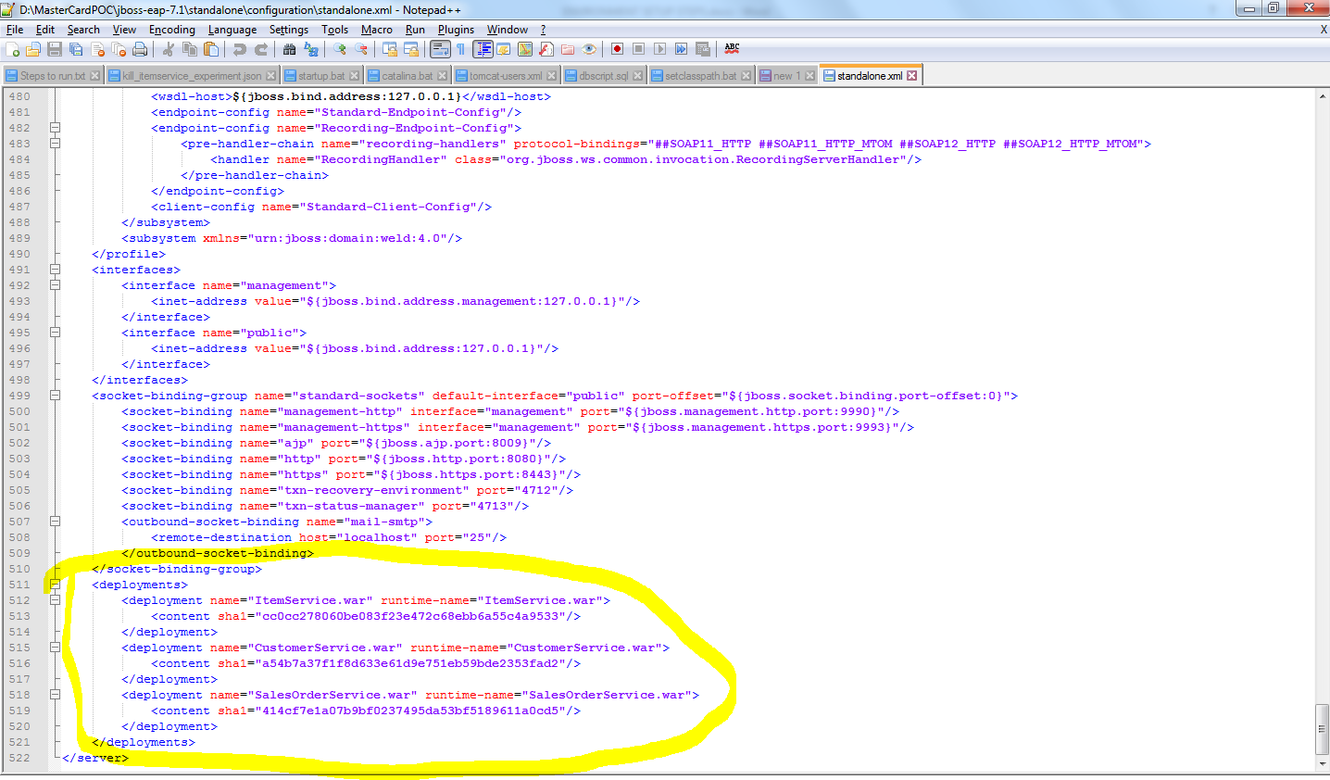

If you see highlighted part ‘<deployments>’ tag in file then remove it and save file:

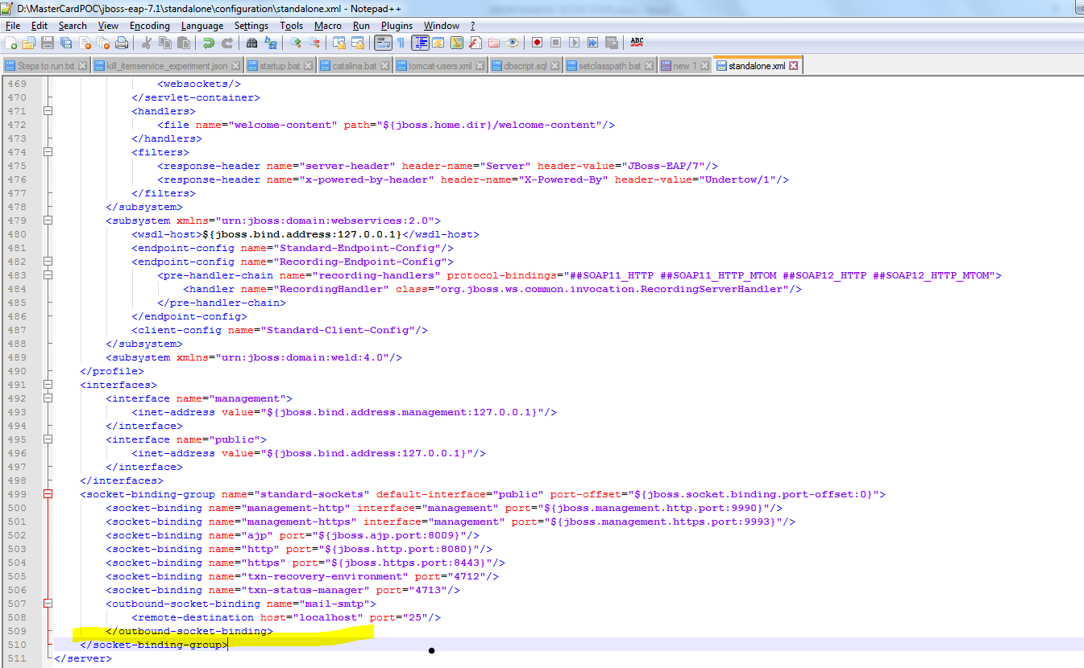

Once these three steps are complete, you have removed any existing deployments. Now bring up node.

## Run Jboss on node1 and deploy services

Goto ‘D:\MasterCardPOC\jboss-eap-7.1\bin’

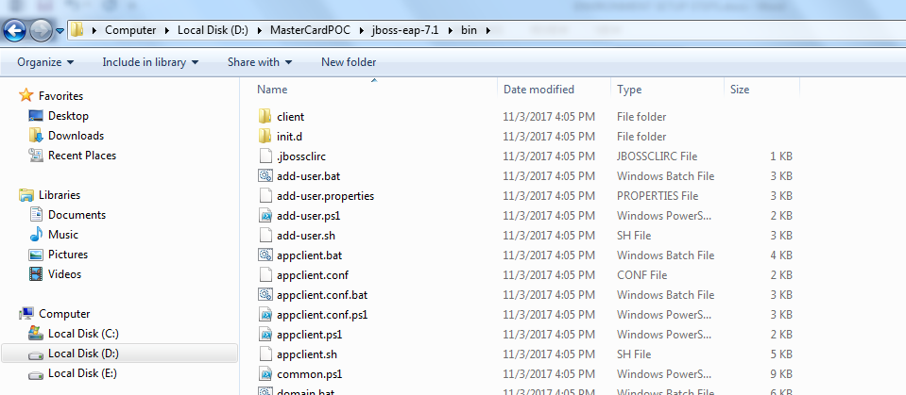

Type ‘cmd’

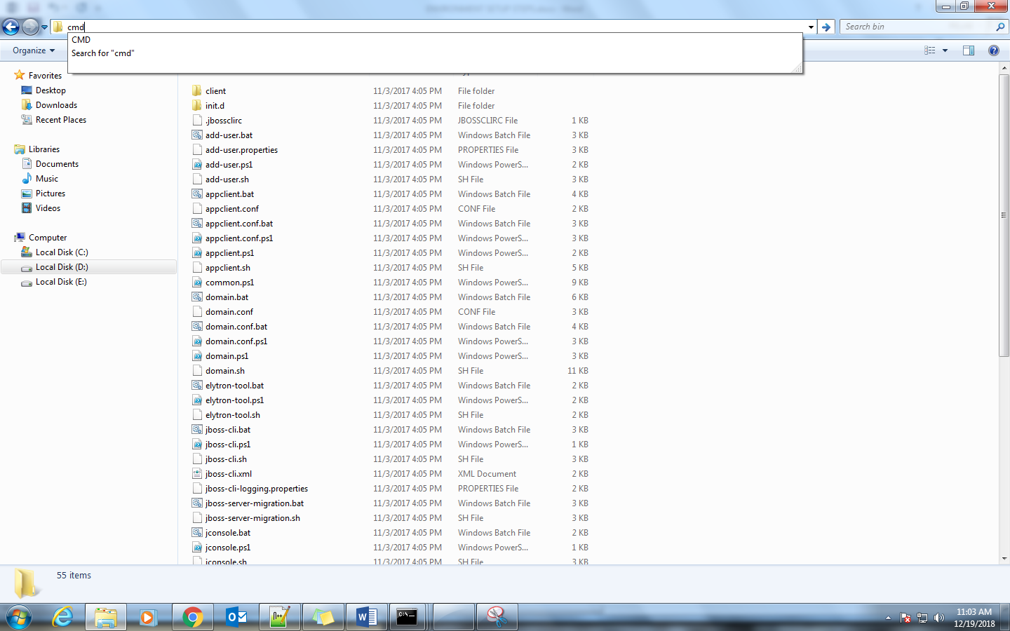

Type command ‘standalone.bat -b INPUHJPC04133’

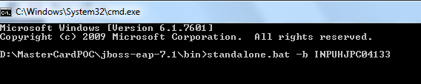

Press enter and wait till you see following log messages:

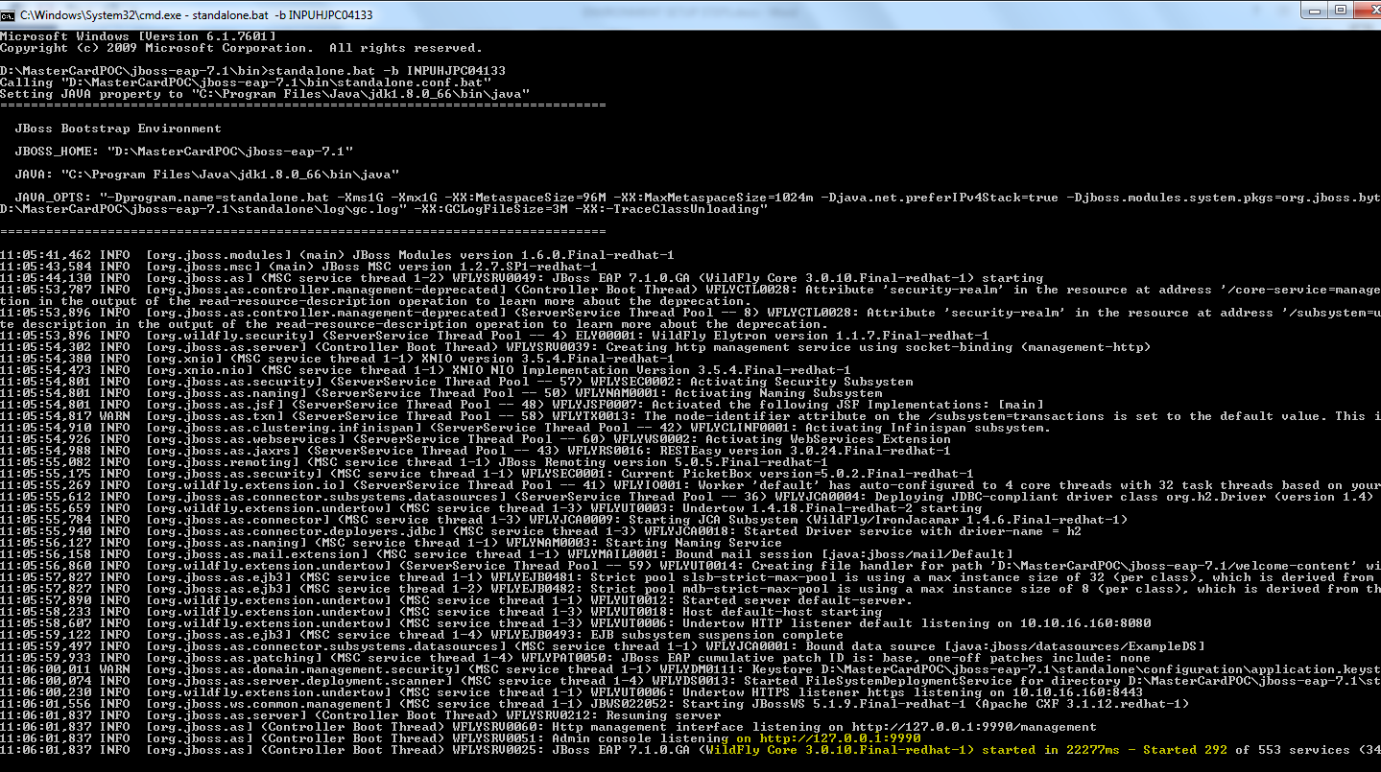

Once you see above highlighted log, JBOSS node is up. Use following URL to launch admin console:

<http://localhost:9990>

username: admin

password: admin

Once you enter password and hit Ok, you should see following screen:

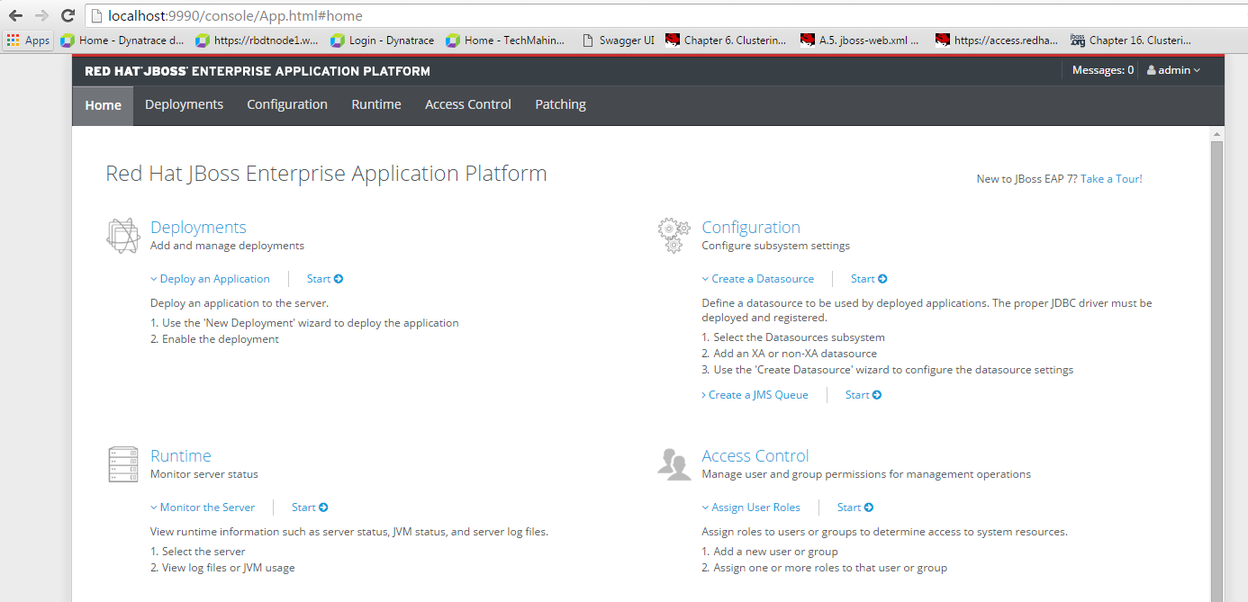

Click on ‘Deployments’:

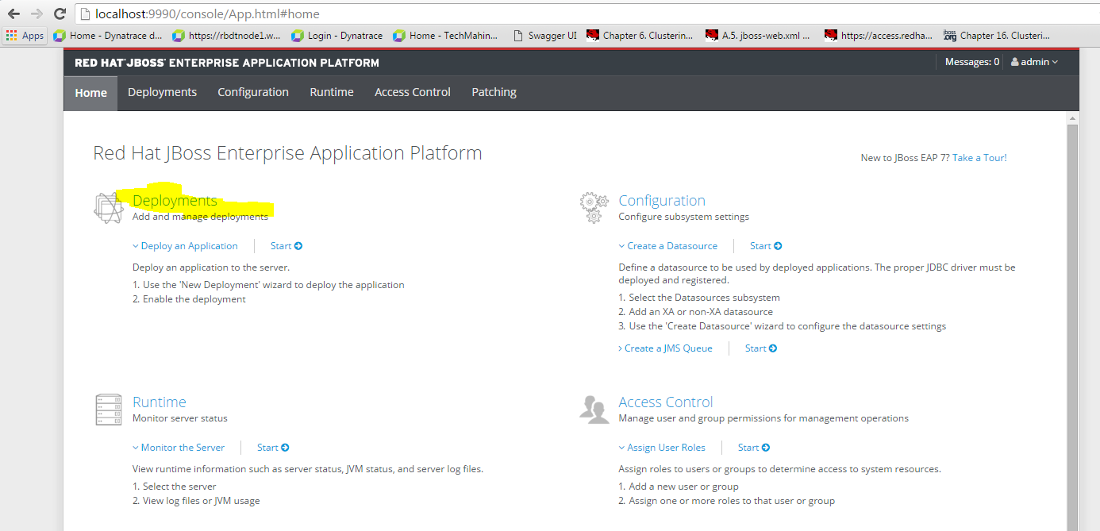

You should see following screen:

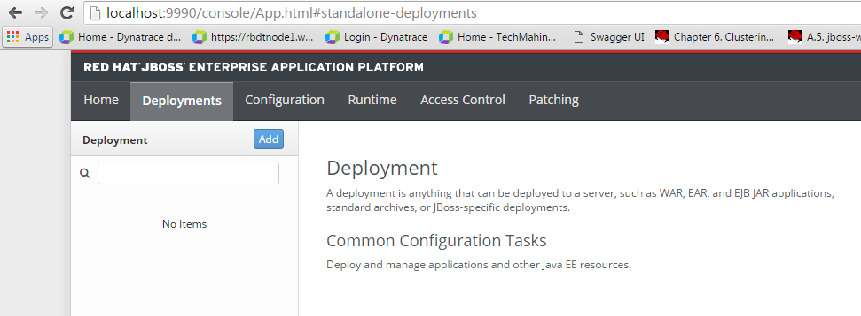

Click on add button:

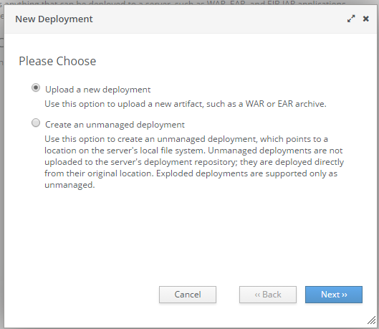

Click on ‘Next’:

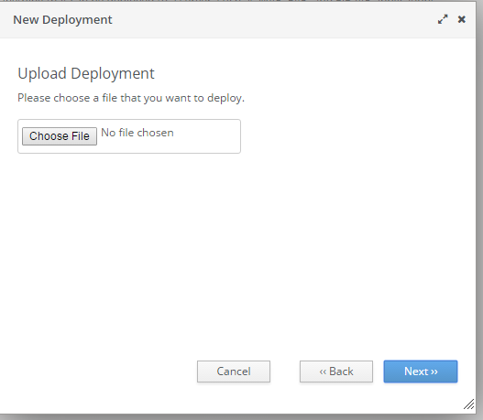

Click on ‘Choose File’ and select war from location ‘D:\MasterCardPOC’:

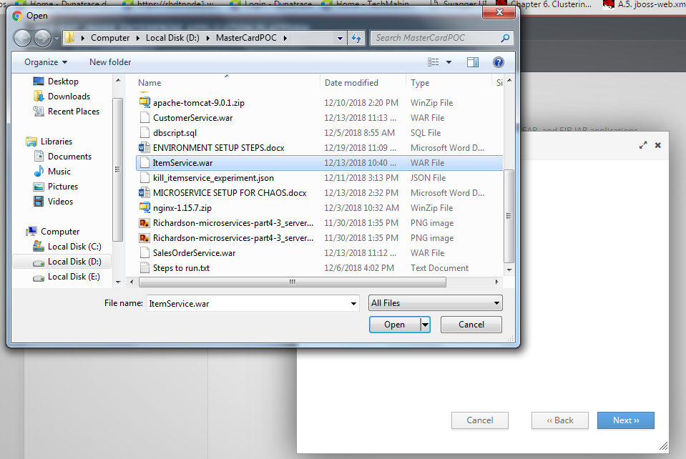

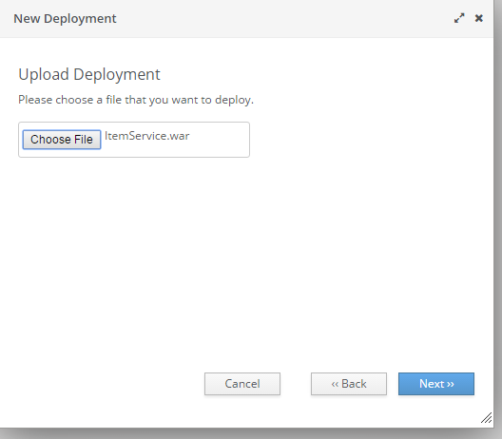

Click on Next and you should see following modal content:

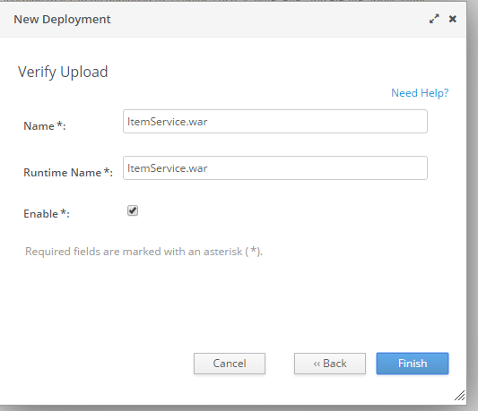

Click on finish and wait for deployment to finish. It might take several minutes.

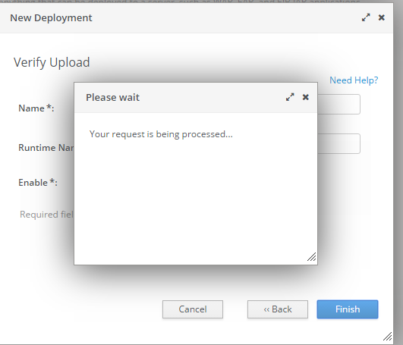

Once you see following screen. Consider ItemService Deployment is successful. 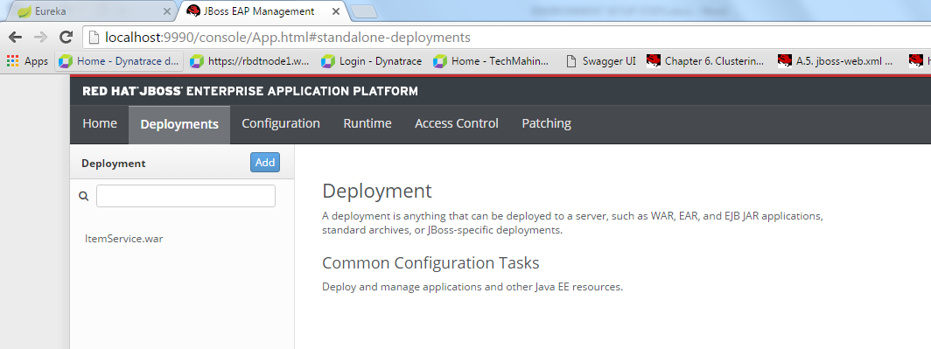

You can validate that using following URL:

<http://inpuhjpc04133:8080/ItemService/swagger-ui.html>

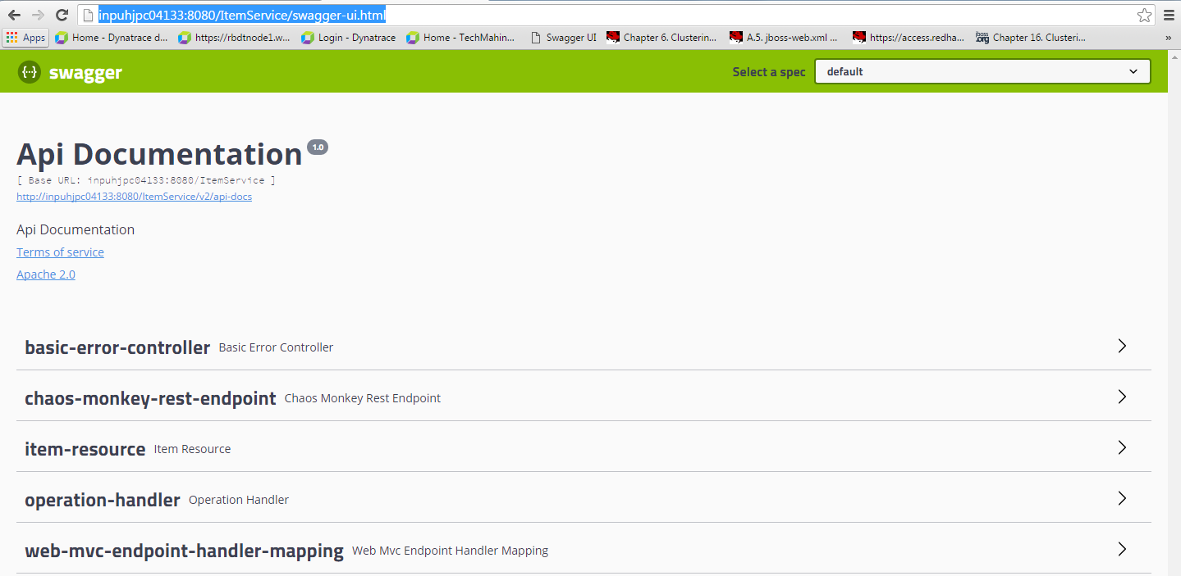

Following Similar steps for Customer Service and Sales Order Service. War files are available in same folder for all services.

# INPUHJPC04128 (JBoss Node2 System)

## Delete existing deployments

Delete ‘tmp’ directory from location ‘D:\MasterCardPOC\jboss-eap-7.1\standalone’



Delete ‘content’ directory from location ‘D:\MasterCardPOC\jboss-eap-7.1\standalone\data’





Open ‘standalone.xml’ in editor:

Go to end of file:



If you see highlighted part ‘<deployments>’ tag in file then remove it and save file:



Once these three steps are complete, you have removed any existing deployments. Now bring up node.

## Run Jboss on node2 and deploy services

Goto ‘D:\MasterCardPOC\jboss-eap-7.1\bin’



Type ‘cmd’



Type command ‘standalone.bat -b INPUHJPC04128’ (Screenshot is of 33 but you need to type 28 for node2)



Press enter and wait till you see following log messages:



Once you see above highlighted log, JBOSS node is up. Use following URL to launch admin console:

<http://localhost:9990>

username: admin

password: admin

Once you enter password and hit Ok, you should see following screen:



Click on ‘Deployments’:



You should see following screen:



Click on add button:



Click on ‘Next’:



Click on ‘Choose File’ and select war from location ‘D:\MasterCardPOC’:





Click on Next and you should see following modal content:



Click on finish and wait for deployment to finish. It might take several minutes.



Once you see following screen. Consider ItemService Deployment is successful. 

You can validate that using following URL:

<http://inpuhjpc04128:8080/ItemService/swagger-ui.html>

Following Similar steps for Customer Service and Sales Order Service. War files are available in same folder for all services.

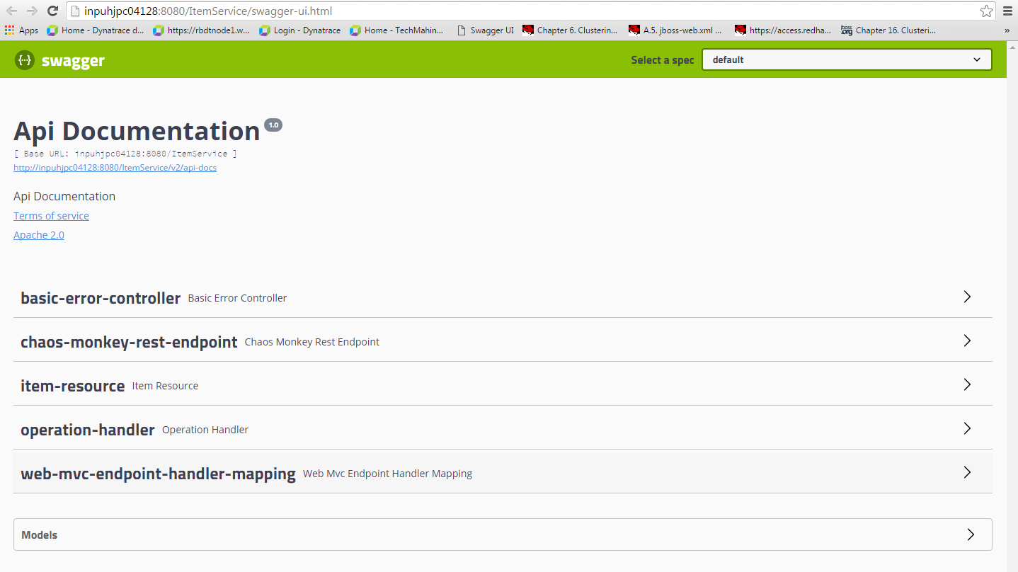

# INPUHJPC01436 (Load Balancer System)

## Run load balancer

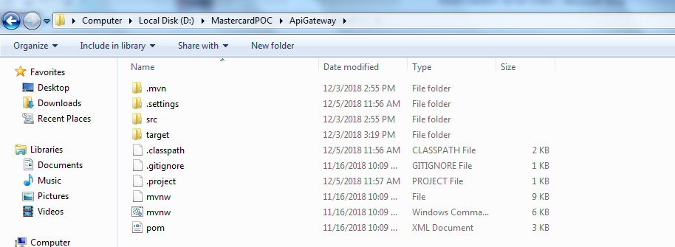

Type ‘cmd’

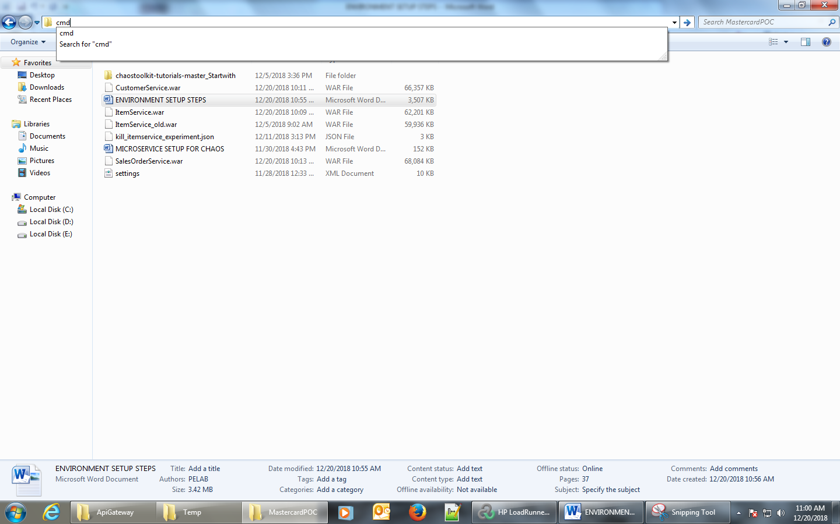

Press enter.

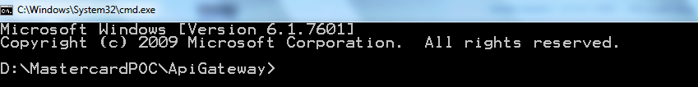

Type command ‘mvn spring-boot:run’.

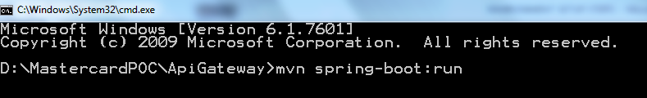

Press enter and wait till it successfully runs load balancer application.

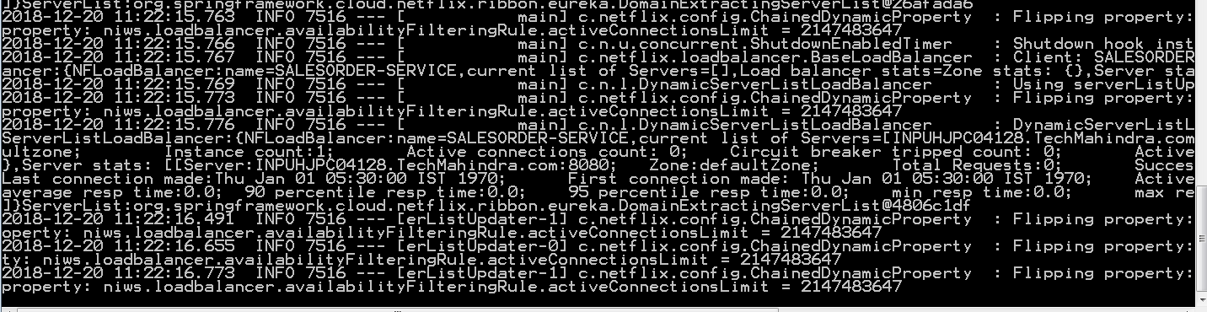

When you see above log messages, Consider load balancer application is up.

URLs to test LoadBalancer:

<http://inpuhjpc04136:5555/customersApi/CustomerService/customers/>

<http://inpuhjpc04136:5555/itemsApi/ItemService/items/>

<http://inpuhjpc04136:5555/salesApi/SalesOrderService/orders/>